Photograph
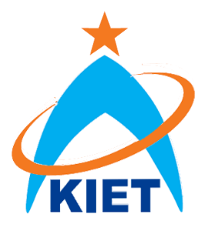
Alumni Association Membership Form

Mission

The mission of KIET Alumni Association is to maintain a life time affiliation with graduates through opportunities, guest speaker sessions, internship and placements and other events & activities to facilitate students and alumni and ultimately to contribute to success of the University.

Full Name:
Reg # Degree / Major:
Email Add (personal):
Graduation Year:
Cell Nos:
Organization Name:
Designation & Dept:
Work Phone:
Please highlight/bold the areas of interest you wish to be involved with:
- Arrangement of sponsorship for different programs
- Arrangement of Internships for students
- Organizing Events / get together
- Fund raising for needy students
- Newsletter
- Alumni Data Update

Note:
- A moderate percentage will be offered to alumni who arrange sponsorship.
- Certificates / Awards will be awarded to active members.

If Alumni wish to support needy students financially or in any above areas, may contact as under;

Corporate Relations Dept.
KIET
PAF Airmen Academy, Korangi Creek,
Karachi.

Ph: 3509-2324-30

Note: Please fill this form and send it to farhan@kiet.edu.pk

